**PROJECT REPORT**

Unveiling Market Insights : Analysing Spending Behaviour And Identifying Opportunities For Growth

|  |  |
| --- | --- |
| **S.NO** | **CONTENTS** |
| **1** | **Introduction** |
| **1.1** | **Overview** |
| **1.2** | **Purpose** |
| **2** | **Problem Definition & Design Thinking** |
| **2.1** | **Empathy Map** |
| **2.2** | **Ideation & Brainstorming Map** |
| **3** | **Result** |
| **4** | **Advantages & Disadvantages** |
| **5** | **Applications** |
| **6** | **Conclusion** |
| **7** | **Future Scope** |

**Table of Contents**

**1.INTRODUCTION**

**1.1.Overview**

Wholesaling or distributing is the sale of goods to retailer to industrial, commercial, institutional or other professional businessman to other wholesalers (wholesale businesses) and related subordinated services. Wholesaling is buying goods in bulk quantity, usually directly from the manufacturer or source, at a discounted rate. The retailer then sells the goods to the end consumer at a higher price making a profit.

The consumption and production of marketed food are spatially separated. Production is primarily in rural areas while consumption is mainly in urban areas.In today's highly competitive business landscape, gaining deep market insights is essential for businesses to thrive and grow. This project aims to analyze customer spending behavior and identify opportunities for growth by leveraging data analytics and data-driven decision-making.

The primary objective of this project is to understand customer spending patterns, preferences, and trends across various dimensions. By conducting a comprehensive analysis, businesses can optimize their marketing strategies, improve product offerings, and enhance customer engagement to drive revenue growth

**1.2.Purpose**

The purpose of implementing the wholesale customer analysis is to get accurately predicting demand and inventory levels, wholesalers can avoid stock-outs and overstocking, reduce waste, and optimize their inventory levels.

It also comes up with several benefits, such as improved accuracy, increased efficiency, and better decision-making.

It helps to overcome the complex challenges in the business and organization entity.

The analysis help wholesalers stay ahead of the competition, reduce costs, and enhance customer satisfaction.

**2.PROBLEM DEFINITION & DESIGN THINKING**

**2.1.Empathy Map**

An Empathy Map is a collaborative tool teams can use to gain a deeper insight into their customers and also will help you understand your user's needs.

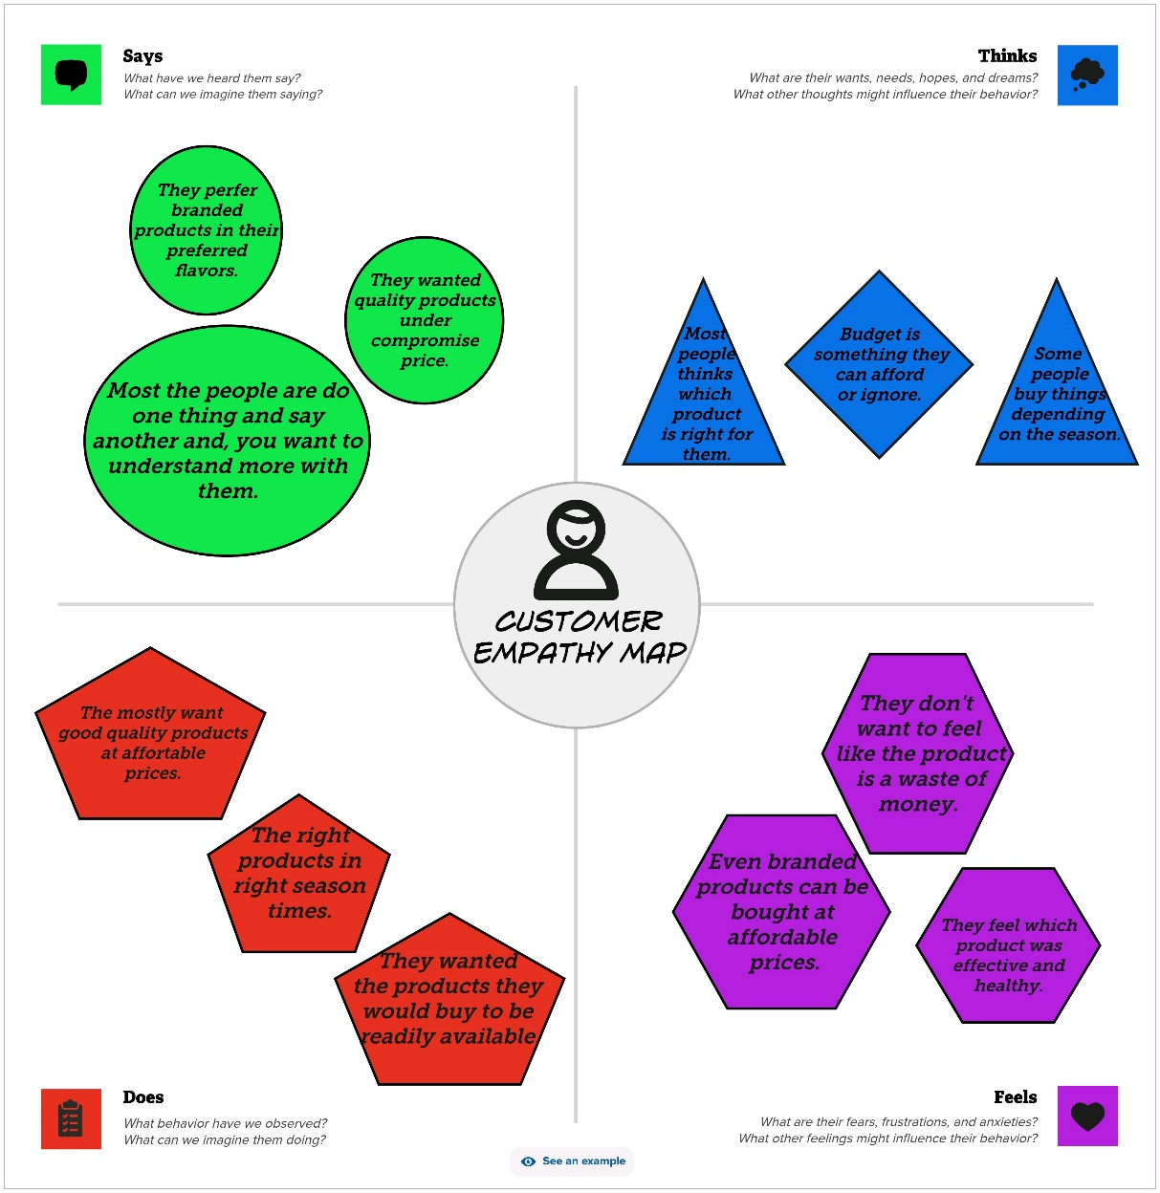

**2.2.Ideation & Brainstorming Map**

Brainstorming is a group problem-solving technique that involves the spontaneous contribution of ideas from all members of the group. It is a tool which allows you to explore a central idea, and all of its related topics, in a non-linear way.

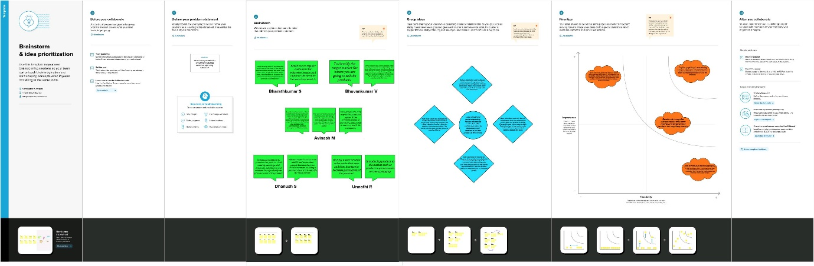

**3.RESULT**

By incorporating the empathy map, brainstorming and with the dataset given we made a visualisation with the help of tableau with a precise output.

The Contents of the datasets were

Channel Detergent

Region Delicatessen

Fresh

Milk

Grocery

Frozen

**DASHBOARD CONTENTS**

1.Milk KPI



2.Grocery KPI



3.Fresh KPI



4.Region Wise Detergent Paper And Grocery

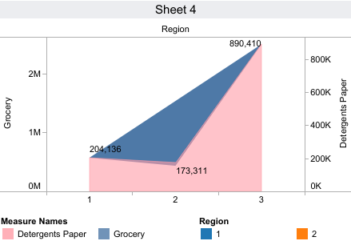

5.Region Wise Milk

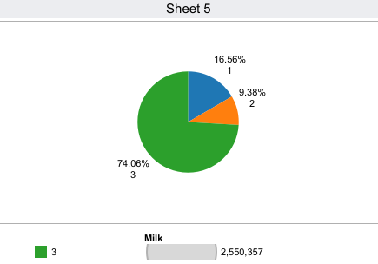

6.Channel Wise Frozen And Delicatessen

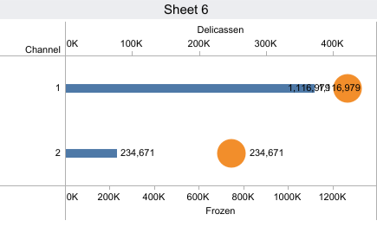

7.Region Wise Delicatessen And Detergent Paper

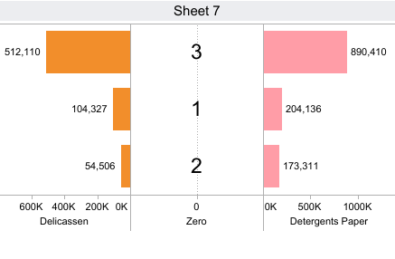

8.Channel Wise Grocery And Detergent Paper

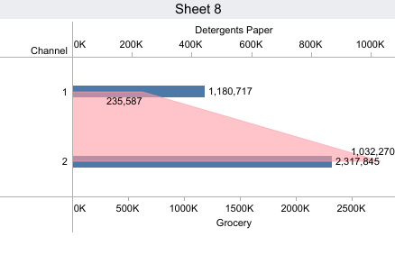

9.Region Wise Delicatessen

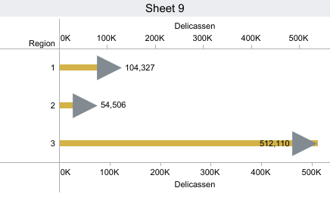

The above eight sheets are the dashboard contents which is developed by merging the different columns from the dataset. It provides the accurate insights about the customer.

**DASHBOARD**

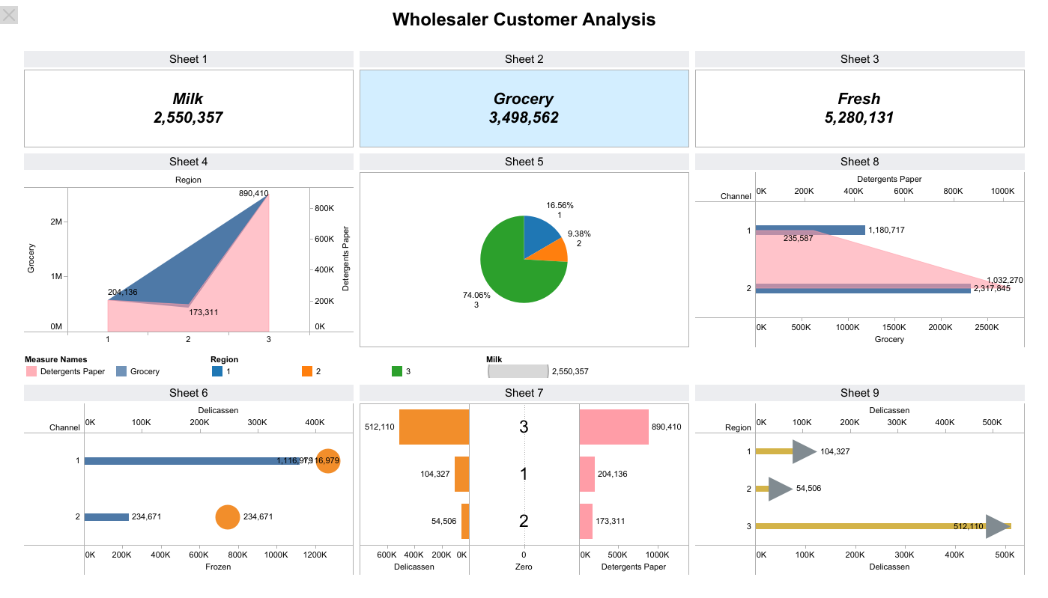

**4.ADVANTAGES & DISADVANTAGES**

**Advantages of Customer Analysis**

Customer analysis plays a crucial role in helping businesses make informed decisions, identify opportunities, and mitigate risks.

By extracting valuable insights from data, businesses can develop effective strategies, refine their products or services, and ultimately drive growth.

It reduce risk, identify emerging trends, and help project revenue.

The Customer Analysis identifies the opportunities for growth.

It helps determine the suitability and sustainability of products in a particular season period in market.

**Disadvantages of Customer Analysis**

The potential disadvantage of market research is how accurately it can represent your target customers. Researchers often struggle to access sample populations that accurately represent the majority of a target market.

Market research also requires businesses to find qualified personnel to perform the research.

Implementing a customer research can be expensive, especially for smaller businesses. Since there are many stages to the process, it can cost a lot of resources for businesses

The common issues in marketing analytics is a surplus of incoming data. This forces you to spend a lot of time and effort to identify which information is most relevant.

Periodic customer analysis is crucial for every organization, without those analysis it will result in a major loss for the organization.

**5.APPLICATIONS**

Analysing what products and how much of each product a customer is likely to order can help businesses manage their inventory more efficiently. This can reduce excess stock and the costs associated with it.

It can identify customers who are at risk of leaving and allow businesses to take proactive steps to retain them. This might involve offering discounts, personalized incentives, or improving customer service.

Wholesale customer analysis can help determine the optimal price points for different customers, taking into account factors like historical purchasing behaviour and market conditions.

Cross-selling and upselling additional products a customer might be interested in based on their purchase history can lead to cross-selling and upselling opportunities. This can increase the average order value.

Demand forecasting what products and how much of each product a customer is likely to order can help businesses manage their inventory more efficiently. This can reduce excess stock and the costs associated with it.

**6.CONCLUSION**

Wholesale distributors continue to play a critical role in the supply chain for most goods, enabling manufacturers to extend their reach while ensuring that retailers can reliably obtain products for sale.

The wholesale industry is a key component of the supply chain, providing a crucial link between manufacturers and retailers. By buying and selling goods in bulk, wholesalers help to ensure that products are available to retailers and, ultimately, to end customers

Here we are concluded the project with the precise visualisation of the dashboard using tableau for the given wholesaler customer dataset dataset.

**7.FUTURE SCOPE**

The wholesale industries are under pressure as consumers shift spending to experiences over things. In order to stay ahead of the curve, it’s important for retailers and wholesalers to understand the latest industry trends and predictions.

Some of the future trends and predictions for technology in the retail and wholesale industries include:

**The continued rise of eCommerce**

According to a report by eMarketer, global eCommerce sales are expected to reach $4.8 trillion by 2021. This represents a compound annual growth rate of 20.2% from 2016–2021. Retailers and wholesalers need to make sure they have a strong online presence in order to stay competitive.

**Omnichannel shopping experiences**

Consumers today want a seamless shopping experience whether they’re shopping online, in-store, or using a mobile app. Retailers and wholesalers must provide an omnichannel experience to meet customer expectations.